|  | 2814ICT/7003ICT – Data Management / Database Design  School of Information & Communication Technology |
| --- | --- |

**Lab 4.1 Exercise**

**1. Write MySQL statements to create a database named MovieCo for the following (partial) ERD and Relational Database Schema.**

You will need write MySQL statements to create the database and two tables in that database.

**Figure 1: MovieCo ERD**

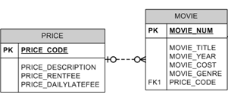

# **Relational Database Schema:**

| **Table Name** | **Field** | **Type** | **Description** |
| --- | --- | --- | --- |
| PRICE | PRICE_CODE | CHAR(2) | PRIMARY KEY |
|  | PRICE_DESCRIPTION | VARCHAR(20) | NOT NULL |
|  | PRICE_RENTFEE | DECIMAL(5,2) |  |
|  | PRICE_DAILYLATEFEE | DECIMAL(5,2) |  |
| MOVIE | MOVIE_NUM | CHAR(8) | PRIMARY KEY |
|  | MOVIE_TITLE | VARCHAR(75) | NOT NULL |
|  | MOVIE_YEAR | CHAR(4) |  |
|  | MOIVE_COST | DECIMAL(5,2) |  |
|  | MOVIE_GENRE | VARCHAR(50) |  |
|  | PRICE_CODE | CHAR(2) | FOREIGN KEY (PRICE_CODE) REFERENCES PRICE(PRICE_CODE) |

**Your answer:**

**Price table**

CREATE TABLE `price` (

`PRICE_CODE` char(2),

`PRICE_DESCRIPTION` varchar(20) NOT NULL,

`PRICE_RENTFEE` decimal(5,2),

`PRICE_DAILYLATEFEE` decimal(5,2),

PRIMARY KEY (`PRICE_CODE`)

) ENGINE=InnoDB DEFAULT CHARSET=utf8mb4

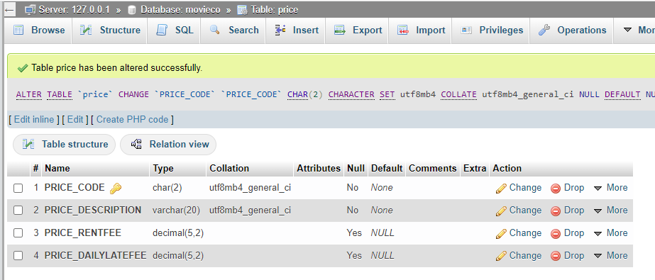

**MOVIE**

CREATE TABLE `movie` (

`MOVIE_NUM` char(8) NOT NULL,

`MOVIE_TITLE` varchar(75) NOT NULL,

`MOVIE_YEAR` char(4) DEFAULT NULL,

`MOIVE_COST` decimal(5,2) DEFAULT NULL,

`MOVIE_GENRE` varchar(50) DEFAULT NULL,

`PRICE_CODE` char(2) DEFAULT NULL,

PRIMARY KEY (`MOVIE_NUM`),

KEY `PRICE_CODE` (`PRICE_CODE`),

CONSTRAINT `movie_ibfk_1` FOREIGN KEY (`PRICE_CODE`) REFERENCES `price` (`PRICE_CODE`)

) ENGINE=InnoDB DEFAULT CHARSET=utf8mb4

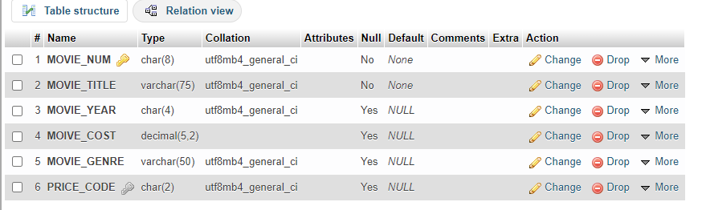

**2. Now write MySQL statements to insert data into the two tables you just created.**

| **PRICE** | | | |
| --- | --- | --- | --- |
| **Price_Code** | **Price_Description** | **Price_Rentfee** | **Price_Dailylatefee** |
| 01 | Standard | 2 | 1 |
| 02 | New Release | 3.5 | 3 |

| **MOVIE** | | | | | |
| --- | --- | --- | --- | --- | --- |
| **Movie_Num** | **Movie_Name** | **Movie_Year** | **Movie_Cost** | **Movie_Genre** | **Price_Code** |
| 00001234 | The Cesar Family Christmas | 2014 | 39.95 | FAMILY | 02 |
| 00001235 | Smokey Mountain Wildlife | 2011 | 59.95 | ACTION | 01 |

**Your answer:**

**1.**

INSERT INTO price(PRICE_CODE,PRICE_DESCRIPTION,PRICE_RENTFEE,PRICE_DAILYLATEFEE)

VALUES ('01','Standard','2','1') ,('02','New Release

','3.5','3')

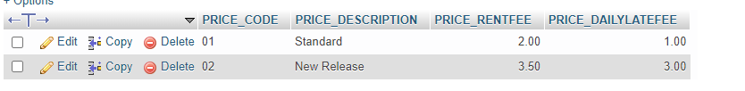

2.

[INSERT](http://localhost/phpmyadmin/url.php?url=https://dev.mysql.com/doc/refman/8.0/en/insert.html) INTO movie (Movie_Num,MOVIE_TITLE,Movie_Year,MOIVE_COST,Movie_Genre,Price_Code) [VALUES](http://localhost/phpmyadmin/url.php?url=https://dev.mysql.com/doc/refman/8.0/en/miscellaneous-functions.html%23function_values) ('00001234','The Cesar Family Christmas','2014','39.95','FAMILY','02') ,('00001235','Smokey Mountain Wildlife','2011','59.95','ACTION','01');

